EU Declaration of Conformity

The manufacturer or his authorised representative established in the Community：Crown Name(WH) United Co.,Ltd. Add: Rm. 1805, Changhang Building, No.69 Yanjiang Avenue, Wuhan Hubei, 430021, China declares that the new PPE described hereafter Respirator CR6620 CR6622 CR6632 CR6920 CR6922 CR6932 CR8322 CR8332 is in conformity with the provisions of REGULATION (EU) 2016/425 (Personal Protective Equipment Regulation) and, where such is the case, with the national standard transposing harmonized standard No EN 149:2001+A1:2009 is identical to the PPE which is the subject of EC certificate of conformity No. CE issued by BSI Group The Netherlands B.V., John M. Keynesplein 9, 1066 EP Amsterdam,the Netherlands. is subject to the procedure set out in Certification under Module B (Annex V) EU Type Examination and Module D (Annex VIII) CONFORMITY TO TYPE BASED ON QUALITY ASSURANCE OF THE PRODUCTION PROCESS , has been issued for these products by BSI Product Services (BSI Group The Netherlands B.V., John M. Keynesplein 9, 1066 EP Amsterdam,the Netherlands ) (Notified Body number 2797).
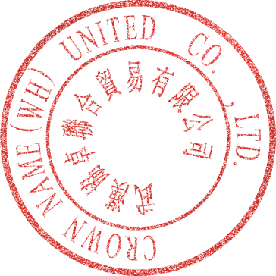
This Declaration of conformity issued under some responsibility of manufacturer Crown Name(WH) United Co.,Ltd.
Done

at Crown Name(WH) United Co.,Ltd. ,on 21, Jan, 2021

Factory Director Lili Signature

