User Instruction
Company Name: Crown Name(WH) United Co.,Ltd.
Address: Rm.1805, Changhang Building, No.69 Yanjiang Avenue, Wuhan, Hubei, 430021, China
Tel: 0086-27-82280600
http://www.crownname.com
Description
These respirators are designed to protect against solid or volatiles liquid article, toxic powder, fumes and mists, in the case of concentrations up to 10 times of Maximum Permissible Workplace Exposure Limit(WEL) or up to 12 times of Normal Protection Factors(NPF) , e.g. wood, metals, resin, glass fibers, quartz, bacteria and micro bacteria, organic or oil aerosol.
Instruction
1. Failure to follow all instructions and limitations concerning the use of the respirator and/or failure to wear the respirator for the whole duration of
exposure to contaminants can seriously reduce the performance characteristics of the respirator and lead to illness, injury or death;
2. Before use, the wearer must first be trained by the employer in the correct use of the respirator in accordance with national regulations;
3. Before enter any contaminated area, require that the wearer be fit-tested;
4. The type and concentration of the hazardous substances must be known;
5. Discard the respirator and replace with a new one if:
•Excessive clogging of the respirator causes breathing difficulty;
•The respirator becomes damaged;
•The respirator has exceeded its’ shelf life.
6. Leave the contaminated area if dizziness, irritation or other distress occurs.
Applications
These respirators are suitable for use in concentrations of solid and non-volatile liquid particles up to the following limits:
Model | EN 149+A1 Classification | Exhalation Valve
CR 6620 | FFP2 NR | Unvalved
CR 6622 | FFP2 NR | Valved
CR 6632 | FFP3 NR | Valved
CR 6920 | FFP2 NR | Unvalved
CR 6922 | FFP2 NR | Valved
CR 6932 | FFP3 NR | Valved
CR 8322 | FFP2 NR | Valved
CR 8332 | FFP3 NR | Valved
Respiratory protection is only effective if it is correctly selected, fitted and worn throughout the time when the wearer is exposed to hazards.
Approvals
These products meet the requirements of the European Community REGULATION (EU) 2016/425 (Personal Protective Equipment Regulation) and are thus CE marked.
Certification under Module B (Annex V) EU Type Examination and Module D
(Annex VIII) CONFORMITY TO TYPE BASED ON QUALITY ASSURANCE OF THE PRODUCTION PROCESS , has been issued for these products by BSI Product Services ( BSI Group The Netherlands B.V., John M. Keynesplein 9, 1066 EP Amsterdam,the Netherlands ) (Notified Body number 2797).

Standards
These products meet the requirements of recently amended European Standard EN 149:2001 + A1:2009, filtering face piece respirators for use against particles. They should be used to protect the wearer from solid and non-volatile liquid particles only.
Products are classified by filtering efficiency and maximum total inward leakage performance (FFP1, FFP2 and FFP3), also by usability and clogging resistance.
Performance tests in this standard include filter penetration; extended exposure (loading) test; flammability; breathing resistance and total inward leakage. Reusable products are also subjected to cleaning, storage and mandatory clogging resistance tests (clogging is optional for non-reusable products). A full copy of EN 149:2001+A1:2009 can be purchased from your national standards body.
Designations: R = Reusable
NR = Non reusable (single shift use only)
FITTING INSTRUCTIONS
CR 6920,CR 6922,CR 6932FITTING INSTRUCTIONS as below：
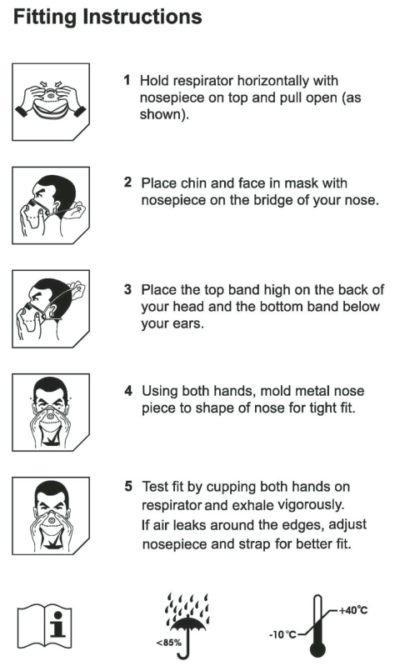

 | 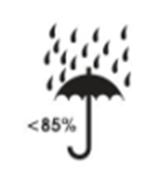 | 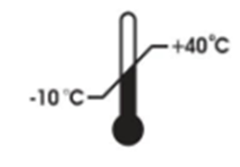
Read direction for use | The product storage conditions ambient humidity | The product storage conditions temperature range
CR 6620, CR 6622, CR 6632 FITTING INSTRUCTIONS as below：
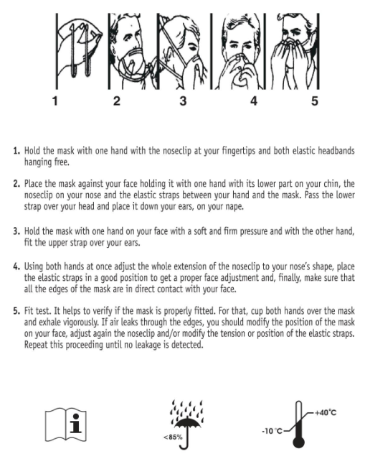

Read direction for use | The product storage conditions ambient humidity | The product storage conditions temperature range

CR 8322,CR 8332 FITTING INSTRUCTIONS as below：
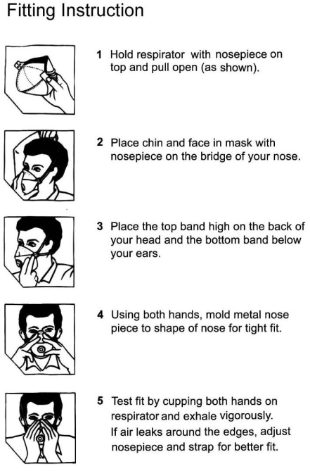
Read direction for use | The product storage conditions ambient humidity | The product storage conditions temperature range

Disposal
Contaminated products should be disposed as hazardous waste in accordance with national regulations
Storage and Transportation
The Series Particulate Respirators have a shelf life of 5 years. End of shelf life is marked on the product packaging. Before initial use, always check that the product is within the stated shelf life (use by date). Product should be stored in clean, dry conditions within the temperature
1. Propose to store these respirators in their original and undamaged packaging indoor with relative humidity of less than 85% and temperatures of between -10℃~40℃ When storing or transporting this product use original packaging provided.
2. These respirators cannot be washed or microwave-heated.
Cleaning
If the respirator is to be used for more than one shift the faceseal/gasket must be cleaned at the end of each shift using the face seal wipe.
DO NOT immerse product in water.
Store cleaned respirator in clean, airtight container.
Warning
See information supplied by the manufacturer before use these respirators. Misuse may result in sickness or death. For more information, see your occupational safety supervisoror contact with manufacturer as upward.
Warning: these respirators do not protect the user against with gases, vapours, radioactive contaminations.
USE LIMITATIONS:
1. Do NOT use the respirator or enter or stay in a contaminated area under the following circumstances:
•Atmosphere contains less than 19.5% oxygen;
•Contaminants or their concentrations are unknown or immediately dangerous to life or health;
•Concentrations or contaminants exceed maximum use concentrations limit according to FFP2 type mask, whichever is lower;
•For sandblasting, paint-spray operations, asbestos.
2. Do NOT modify or misuse the respirator;
3. Do NOT use the respirator with beards or other facial hair that interferes with direct contact between the face and the edge of the respirator, or any other conditions that may prevent a good face-seal;
4. Do NOT use in explosive atmosphere.
5. One respirator mask shall not be used for more than one shift.
WEBSITE FOR DOC
https://www.crownname.com/Certifications/CE-Declaration-of-Conformity.html

